January 2017 Further information: David Reece +44 (0)1453 523968
Combining Raman microscopy with scanning electron microscopy (SEM) to study inorganic and mineral samples at the Geological Institute of Romania, Bucharest.
The Geological Institute of Romania, located in Bucharest, was founded in 1906. It is famous for its museum which hosts a collection of more than 80,000 samples of rocks, fossils and minerals from all over Romania.
Oana-Claudia Barbu and Daniel Bîrgăoanu are both PhD students and research assistants in the electron microscopy laboratory, known as MICROCOSMOS, where they study inorganic and mineral samples. They use Renishaw’s structural and chemical analyser (SCA) interface to bring the Raman analysis capabilities of the inVia™ confocal Raman microscope to their scanning electron microscope (SEM). The inVia and SCA interface provide an in-SEM analytical technique that allows co-located chemical information and the flexibility of a fully functioning Raman microscope.
Ms Barbu commented, “This allows us to perform high resolution analysis on geological samples using energy dispersive spectroscopy (EDS) and Raman spectroscopy. Our Zeiss SEM is also equipped with electron back scattering (EBSD) and wavelength dispersive (WDS) detectors to give even better correlation of results. The system is easy to use and has user-friendly analysis software (WiRE 4™) that provides us with high definition chemical images from our very large Raman datasets. We greatly appreciate the strong support we have received from Renishaw.”
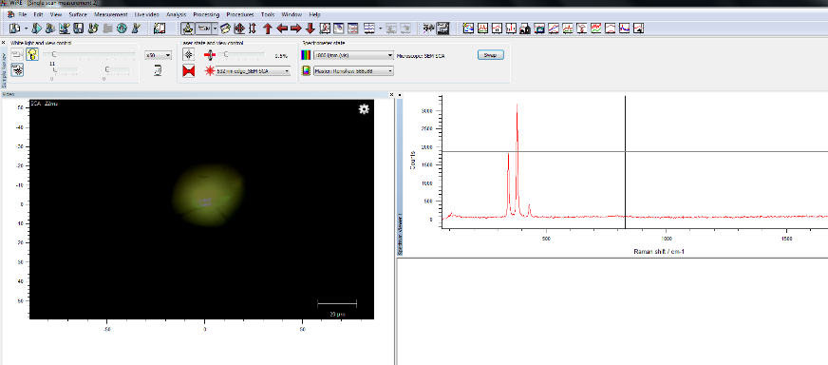
An example, typical of their work, is the study of mining waste to better understand its composition. In both the Raman spectrum and EDS analysis below, the metallic mineral content is identified as pyrite (iron sulphide, FeS₂).
Please visit www.renishaw.com/earthsciences for further details on how Raman microscopy is being used in earth sciences applications. For more details of Renishaw’s co-located SEM-Raman system, visit www.renishaw.com/SEMRaman

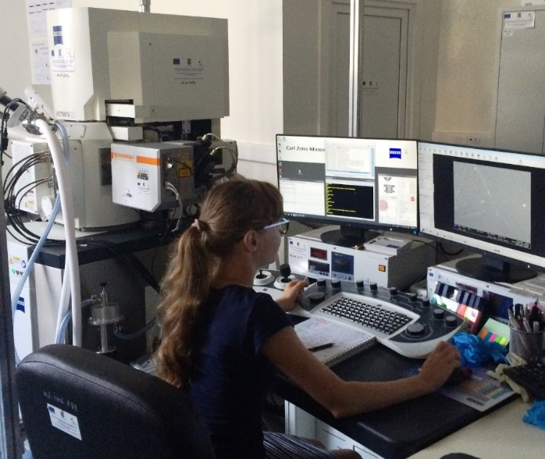
Image: Renishaw’s SCA interface is shown mounted with a Zeiss electron microscope at the Geological Institute of Romania in Bucharest. The user is Oana-Claudia Barbu.
-ENDS-
About Renishaw

Renishaw is one of the world's leading engineering and scientific technology companies, with expertise in precision measurement and healthcare. The company supplies products and services used in applications as diverse as jet engine and wind turbine manufacture, through to dentistry and brain surgery. It is also a world leader in the field of additive manufacturing (also referred to as 3D printing), where it is the only UK business that designs and makes industrial machines which ‘print' parts from metal powder.

The Renishaw Group currently has more than 70 offices in 35 countries, with over 4,000 employees, of which 2,700 people are employed within the UK. The majority of the company's R&D and manufacturing is carried out in the UK and for the year ended June 2016 Renishaw achieved sales of £436.6 million of which 95% was due to exports. The company's largest markets are the China, USA, Germany and Japan.

The Company's success has been recognised with numerous international awards, including eighteen Queen's Awards recognising achievements in technology, export and innovation. Renishaw received a Queen’s Award for Enterprise 2014, in the Innovations category, for the continuous development of the inVia confocal Raman microscope. For more information visit www.renishaw.com

For further information

Please contact:
David Reece
Renishaw plc
New Mills
Wotton-under-Edge
Gloucestershire GL12 8JR UK
Tel: +44 1453 523968 (direct)
Tel: +44 1453 524524 (switchboard)
Email: david.reece@renishaw.com
www.renishaw.com/raman

