March 2016

Renishaw’s inVia™ confocal Raman microscope wins CS Industry Award 2016
Renishaw, the global engineering technologies company, is delighted to announce that it has received a CS Industry Award 2016, in the Metrology category, for its inVia Raman microscope. The CS Industry Awards are organised by Compound Semiconductor magazine and voted for through the website www.compoundsemiconductor.net. Together these deliver comprehensive coverage of the compound semiconductor industry.
The CS Industry Awards, which are now in their sixth year, showcase the success of companies within the compound semiconductor industry, including those with innovative equipment that contributes to the growth of this industry. From lighting homes to empowering mobile devices and harnessing the energy from the sun, compound semiconductors are playing an ever-increasing role in modern life. The Metrology Award has been granted for the inVia’s ability to examine silicon carbide (SiC). The judges commented: “Raman spectroscopy has a reputation as a difficult, time-consuming technique. The inVia changes all that, making it easy and quick to gather Raman spectra and Raman maps.”
“This is the first time that the inVia has been shortlisted for this award, so we were delighted to be announced as winners” said Simon Holden, Director and General Manager of Renishaw’s Spectroscopy Products Division. “Semiconductor and 2D/3D materials are used in a growing range of devices that increasingly impact on all our lives. For this to continue, it is vital that manufacturers can characterise these materials in a reliable, repeatable and quantifiable manner. We are delighted that our efforts to develop the inVia confocal Raman microscope have been recognised in this application area and we hope that it will continue to contribute to cutting edge research, manufacturing improvement and Quality Assurance within this growing industry.”
Renishaw’s inVia microscopes use a form of light scattering (Raman scattering) to analyse the chemical structure and composition of materials. It is of major benefit to academics and industrialists who use inVia to tackle analytical problems across a broad range of application areas, including, chemicals, materials science, pharmaceuticals, semiconductors, forensics, gemmology, antiquities and green energy development, such as photovoltaics.
The properties of silicon carbide are highly dependent on its crystal structure (it can exist in many polytypes), on the quality of the crystal and on the numbers and types of defects present. Manufacturers of silicon carbide raw material and devices need to monitor and control these attributes to enhance yield.
The inVia’s non-destructive analysis can determine the crystal form, quality and the nature of defects in SiC and other compound semiconductors, as well as the stress and free carrier concentration distribution. It acquires spectra incredibly quickly and generates Raman images ranging from detailed 3D images of single defects to whole wafers.
The new inVia™ Qontor™ Raman microscope, equipped with LiveTrack™ focus tracking technology, opens up even more opportunities for advanced SiC research. The bowing of some SiC wafers, caused by stress, can be problematic for Raman mapping, however LiveTrack’s continuous real-time focus tracking system enables even highly-bowed wafers to be successfully mapped. With no sample preparation required, whole wafers can be analysed at any stage of the production process, and without damage to the sample being analysed.
The CS Industry Awards were this year presented at a ceremony held in Brussels, Belgium, with the Metrology Award accepted on behalf of Renishaw by the General Manager for Benelux, Philippe ReindersFolmer.
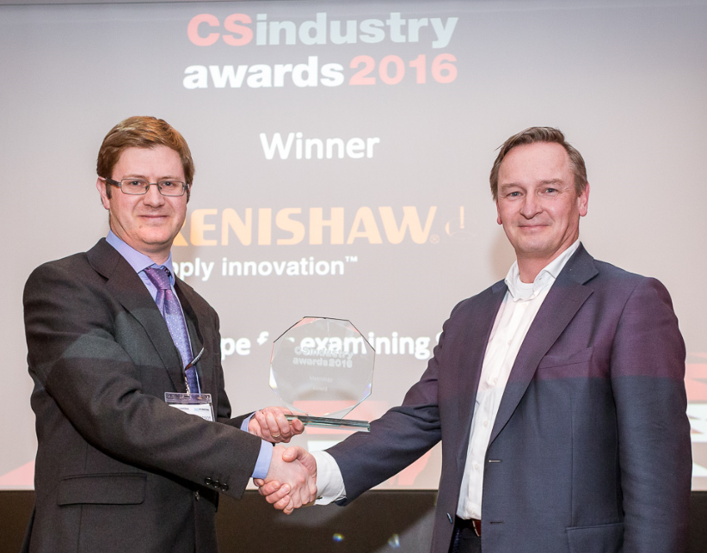
Please visit www.renishaw.com/go/sic for further details about Raman analysis of semiconductor materials.
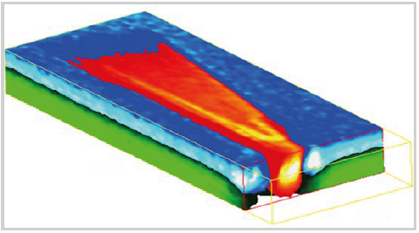
Image: Philippe ReindersFolmer, General Manager, Benelux (right), accepting the Award.
Image: ‘Comet’ defect in a SiC wafer, showing doped 4H-SiC substrate (green), 4H-SiC epilayer (blue), and 3C-SiC inclusion (red/orange). The mapped region is 70 × 25 × 7 µm³
-Ends-

About Renishaw
Renishaw is one of the world's leading engineering and scientific technology companies, with expertise in precision measurement and healthcare. The company supplies products and services used in applications as diverse as jet engine and wind turbine manufacture, through to dentistry and brain surgery. It is also a world leader in the field of additive manufacturing (also referred to as 3D printing), where it is the only UK business that designs and makes industrial machines which ‘print' parts from metal powder.
The Renishaw Group currently has more than 70 offices in 35 countries, with over 4,000 employees, of which 2,700 people are employed within the UK. The majority of the company's R&D and manufacturing is carried out in the UK and for the year ended June 2015 Renishaw achieved sales of £494.7 million of which 95% was due to exports. The company's largest markets are the USA, China, South Korea, Germany and Japan.
The Company's success has been recognised with numerous international awards, including eighteen Queen's Awards recognising achievements in technology, export and innovation. Renishaw received a Queen’s Award for Enterprise 2014, in the Innovations category, for the continuous development of the inVia confocal Raman microscope. For more information visit www.renishaw.com

For further information
Please contact:
David Reece
Renishaw plc
New Mills
Wotton-under-Edge
Gloucestershire GL12 8JR UK
Tel: +44 1453 523968 (direct)
Tel: +44 1453 524524 (switchboard)
Fax: +44 1453 523901
Email: david.reece@renishaw.com
www.renishaw.com/raman

